Tab 1

DataFest 2026 Challenge
Do NOT reveal the source of the data or any features of the data to ANYONE before May 2. This will ensure that all ASA DataFest participants around the globe have the same experience with the data as you. This means not posting anything to social media that might reveal clues, and ensuring that public GitHub repositories are not discoverable (and, if they are, that identifying work is removed).

Stormont Vail Health
Stormont Vail Health (SVH) is a nonprofit integrated health system serving Kansas for more than 130 years. Stormont Vail has been recognized as a Magnet organization by the American Nurses Credentialing Center since 2009. It is composed of Stormont Vail Hospital in Topeka, a 586-bed acute care hospital, Stormont Vail Flint Hills Hospital in Junction City, a 92-bed acute care hospital, Stormont Vail Health Behavioral Health which includes a 52 bed inpatient unit and various outpatient/ambulatory services, Five urgent care centers in Topeka, Stormont Vail Health Manhattan Campus, a primary care, specialty care, and imaging clinic, and Cotton O'Neil Clinic, a multi-specialty physician group with more than 500 providers, including more than 270 physicians. More than 6,000 employees provide care and support services for patients in hospitals and 35 other locations, including the Cotton O'Neil Heart Center, Cancer Center, Diabetes & Endocrinology Center, Digestive Health Center, Pediatric clinics, and 10 regional primary care clinics. In total, SVH has over 2.7 million square feet of facilities across the system. Annually, SVH has 21,296 inpatient discharges, 185,609 outpatient services, 917,634 clinic visits, more than 80,000 virtual visits, and has over 267,000 MyChart Patient Portal Users. SVH is the busiest trauma center in Kansas and the only ACS Level II Trauma center in the region. In addition, SVH has the only Level III NICU in the region.

SVH’s mission is to improve the health of the community by being a national leader in providing compassionate, high-quality, efficient, integrated care through collaboration that results in a healthier community. To that end, they are providing you with data on patient encounters at their clinics and hospitals over a four-year period, beginning in 2022.

Service Area: The Stormont Vail Health service area and outreach include 19 counties in Northeast Kansas (population 633,895), with 51% of the service area population in five cities: Topeka (125,467), Lawrence (92,271), Manhattan (54,700), Emporia (24,354), and Junction City (22,053). The service area is predominantly rural, with the average town having a population of less than 1,000. There are four primary corridors (Table 1) surrounding Shawnee County (“Central”, population 172,942).

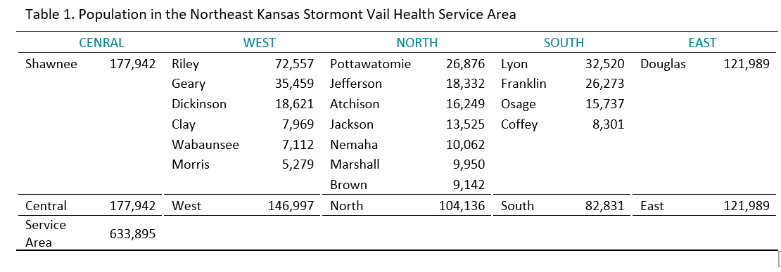

Challenge
Health administrators see only a static snapshot of patients' experiences as they pass through the system. These data offer the possibility for developing longitudinal pictures of patients' "journeys" through the system. The notion of a patient journey is relatively new in health care research. Essentially, a journey begins when the patient seeks medical care for an issue, receives a primary diagnosis, and consists of all visits centered on that diagnosis.

SVH is asking for your help in describing patient journeys to better understand how their system can be adjusted to meet patients' needs. For example, do patients experience long gaps between diagnosis and future appointments? Do they receive "too many" repeated tests? Does their home environment tell us anything about this? Are there transportation issues that might affect this? Do different patient communities have different "typical" journeys? Does journey type vary by the type of illness or care sought?

Caution: Be wary of sweeping generalizations of patient journeys. Some journeys might have begun before our data "window" opens; others, probably many, will continue beyond the last date in the data set.

Getting started: Although the Challenge is stated quite broadly, you should feel free to focus on smaller areas. Indeed, you are encouraged to do so. You might, for example, focus on certain types of visits or diagnoses. You might focus on patients who respond in a particular way on the social determinants scale, or on patients who fall into particular age groups.

The context is very challenging in this data set. Google may be your friend in helping you define and understand terms. The Read Me file provides some context and helps you understand the data structure.

Every file provided links to one or more other files. The "keys" that match one row in File A to a row in File B sometimes have different names in the two files. For example, in the encounters file, you can use the AttendingProviderDurableKey to locate that provider in the providers file. But in the providers.csv file, the name of the variable to link to is named, simply DurableKey. In the patients.csv file, the same name, DurableKey, is used to identify patients. And it links to PatientDurableKey in the encounters.csv file. The Variable Definitions file will help keep these straight.

Spend a lot of time thinking about questions about the context. But don't feel you have to choose one big, important (and impressive) question right away. Start with small questions, answer them (or don't), and see where they lead you. Eventually, if you keep asking "and why is that?" and "but what about this?" and "how does this compare to that?", a larger story will develop.

Note on Health Insurance Portability and Accountability Act (HIPAA): Patient confidentiality is a core tenet and a legal obligation at SVH. The data you are working with is fully anonymized patient encounter data and complies with HIPAA regulations.
Stormont Vail worked closely with the ASA DataFest team to ensure the data was appropriately de-identified.

Rules for Generative AI Use
Be aware that many generative AI models, particularly free or publicly available versions, use your prompts and inputs to train. If you input DataFest data into these models, you are breaking the proprietary notification (see below). To protect the data, you are required to abide by these guidelines.
- Do not upload, paste, or otherwise input any portion of the DataFest datasets provided to you into any generative AI product. This includes free chatbots, online modeling tools, or any platform whose data-handling policies you cannot verify.
- You may only use generative AI models that do not store your input or use it for training their models. Most generative AI products licensed by universities and colleges meet this condition. Check with your institution to verify. If you are participating in a DataFest that is off-site from your institution, then you may be required to use a VPN to access your institution's licensed versions of these AI models.
- If using coding assistants (e.g., GitHub Copilot for R or Python), do not type, print, display, or preview any portion of the dataset in the script, source, or prompt window of the AI assistant. Use these tools only for general coding support (e.g., syntax help, debugging patterns), not for data-driven suggestions that would require the model to see the data.

Proprietary Notification
Data for DataFest is not public. These data are proprietary and are only to be used for the purpose of the American Statistical Association’s DataFest.
By using this data, you agree to the following:
- During participation in ASA's DataFest, store and manage the data securely and privately. This means you may NOT upload the data to websites that may provide access to the data to anyone other than yourselves. (For example, if using Tableau or GitHub, make sure privacy settings prevent others from seeing or accessing the data.) If you are not sure, then don't use that service! (Note: RStudio Cloud does not have access to your data; therefore, you can use it.)
- Erase all data after your ASA's DataFest participation is complete.
- Do not identify or attempt to identify the people whose information is contained in the dataset, nor contact any of the individuals whose information is contained in the dataset.
- Comply with all applicable U.S. federal and state laws and regulations relating to the maintenance of the dataset, the safeguarding of the confidentiality of the dataset, and the use and disclosure of the dataset.
- Do not publish results of your analysis of the data, except that the final products of the competition (video, slide deck, one-page summary) may be displayed on team members' websites and on campus ASA DataFest websites.
- Do not share the data with anyone who is not an ASA DataFest participant.
Finally, please do NOT reveal the source or any features of the data to ANYONE before May 2. This will ensure that all ASA DataFest participants around the globe have the same experience with the data as you. This means not posting anything to social media that might reveal clues, and ensuring that public GitHub repositories are not discoverable (and, if they are, that identifying work is removed).

